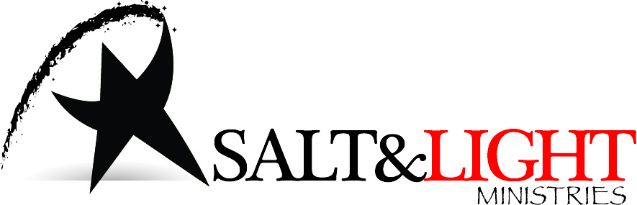

Capital Coordinator
God Rods Across America Tour

First of all, thank you for your interest in helping us celebrate the faithfulness of God in this ministry for 30 years. This is a EASY job, but we need folks just like you to help us pull it off in each state. Here’s what you need to know!

What is a Capital Event in our God Rods Across America Tour?

- A Celebration of God’s faithfulness over 30 years of ministry through Salt and Light Ministries. The event will last 20-30 minutes.
- A performance of “Arise My Love” using the God Rods; a signature piece of this ministry that has been used by thousands of people across the world over the last two decades. Anyone who has ever used the God Rods or participated in “Arise My Love” as a ministry performance piece is invited to attend and join the celebration.
- A short time of corporate prayer for state and federal leaders as they rely on God for wisdom and guidance. (Traditional Judeo-Christian Worldview of God.)

Responsibilities:

- First off, give me a call or send me an email:
  - jeff@saltandlightmin.org
  - 804-690-2778
We’ll schedule a date in conjunction with our schedules. Once we have the date…
- Schedule the event at the state capital going through proper channels. In Virginia, I had to schedule this event through the state department of General Services, Division of Engineer and Buildings. Here is the information that they requested, which should be helpful in preparing your response
  - Event/Organization: Corporate Prayer for State/Federal Leaders
  - Website: saltandlightmin.org
  - Requested Date/Time: 30 minutes
  - Number of people expected: 5-20
  - Description of Event: Short Dramatic Presentation of “Arise My Love” followed by prayer for state and federal leaders.
  - Equipment set-up:
    - Small portable PA system provided by Salt and Light Ministries
    - No other equipment or set up necessary.
  - Official invited to attend: NONE
  - Individual Responsible for Event Conduct: Your name and MINE, Jeff Smith. My address is 6420 Glebe Point Road, Chesterfield, VA 23838.
  - 804-690-2778. Jeff@saltandlightmin.org.
- Serve as a liason between Salt and Light Ministries and participants in the state who may have questions or concerns about the event and specific details. Make your contact information known for this purpose.

Salt and Light Ministries will be responsible for:
- Leading the on-site event.
- Providing PA equipment, God Rods and any other equipment necessary for the event. Also to provide set up and tear-down which are very minimal.
- Promoting and marketing the event through our website at www.saltandlightmin.org. Any help that the Capital Coordinator can do is greatly appreciated, but not necessary.

If you have further questions, please contact me. I am very grateful for your consideration and look forward to working with you on this project.

Jeff Smith
Director, Salt and Light Ministries.

