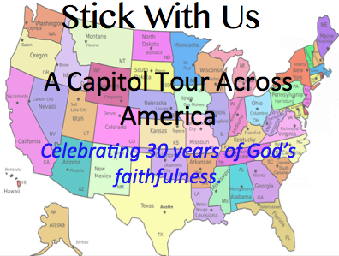

STATE: Minnesota

Capitol: Minneapolis/St Paul

Contact: Jeff Smith

Date/Time: August 10th, NOON.