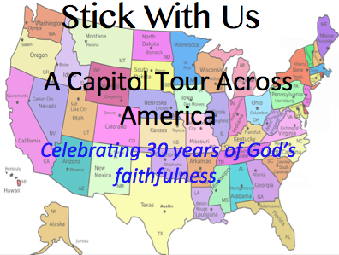

STATE: North Dakota

Capital: Bismark

Contact: Jeff Smith

Date/Time: Aug 11th, 1PM