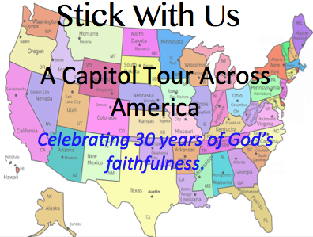

STATE: Nebraska

Capital: Lincoln

Contact:

Date/Time:

Notes:

This state has not yet been scheduled. If you would like to be a [Capital Coordinator](file://localhost/Users/jeffsmith/Desktop/God%20Rods%20Across%20America/Capital%20Coordinator.docx) for this state, click the link for information.