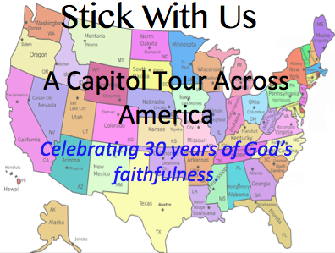

STATE: Wisconsin

Capital: Madison

Contact: Jeff Smith

Date/Time: Aug 9th, 7PM