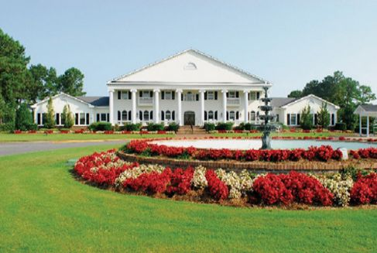

Mastors Men’s Golf Outing, April 8-10, 2020
Brunswick Plantation and Golf Resort
330 S Middleton Dr NW, Calabash, NC 28467 (800) 848-0290

Welcome to the Mentor Men’s Golf Outing. My name is Jeff Smith and I’m coordinating this year’s men’s golf event at Brunswick Plantation and Golf Resort in Calabash, NC, not far from Myrtle Beach.
I wanted to send you this information sheet that will (hopefully) answer any questions you have about the event. If you have further questions, please contact me at jeff@saltandlightmin.org or 804.690.2778.
Our Group is the “Smith-Masters” Group. You can register on line using the following information:
Reservation Number: 1660983
Arrival Date: 4/7/2020
TO JOIN THIS GOLF PACKAGE, CLICK HERE
Or, copy and paste the line below into your browser
https://coastal.w3effect.golf/golfcentral/guests/Register.aspx?g=3aef1e60-13ba-4e8d-ad0b-dd961ead64cd

Anyone at the staff can take your reservation at 800-332-8576. My primary point of contact is Chase McGraw. No money for this event goes through me unless it is a sizeable donation to Jeff Smith Ministries!!!!

Our golf schedule is as follows:
  - April 8: 8:24 Tidewater Golf Club
  - April 9: 9:00 Pearl West Golf Course
  - April 10: 8:04 Brunswick Golf Plantation
- There is a 9-hole replay included with your package that you can use any time during your stay. If you would like to arrive early and use it on April 7th, you will need to make arrangements with the golf course. Again, use the name “Smith-Masters” when making any reservations associated with this outing.
- Cost per golfer is $335. This includes golf, lodging, taxes, and resort fees. It does not include meals, tips, snacks, etc. This is about $20 more than last year, but two of the courses (Tidewater and Pearl West) are rated significantly higher that the course we were on last year.
- Your full payment is due by March 8th. There is NO cancellation fee outside 30 days of the event, other than credit card fees (5%). Inside of 30 days you are responsible for credit card fees and all room costs. Inside of two weeks of the event, (14 days) there is no refund of paid fees.
- They will however, provide rain checks for use on the course. If you’re joining us start praying NOW for great weather!!! (Yes, we do that!)
- Lodging is for three nights at the Brunswick Plantation and Golf Resort. www.brunswickplantation.com. We will be staying in villa condos that have 2 bedrooms and 2 bathrooms per condo. There are 4 men to a condo. Each bedroom has two beds. (This is a men’s event only.) If you have specific requests for roommates, please make that known to the concierge when you sign up. If you need a roommate, we can work it out. Check in on April 7th is 4:00PM, although updates on earlier arrivals are made through text messaging. Check out is April 10th. Villas are second story, which is 10% cheaper. If you would like a first floor lodging, you can make that request directly to Chase McGraw.,
- Meals. There is no formal meal package. But this is one of the best parts about Calabash. Trust me….You WANT to eat out. Oh, it’s soooo good.
- Tournaments. We will have some golf ‘games’ for your consideration each round, although, I’m not sure how formal this will be and you are not required to participate. There’s no money involved that I know of!
Just a note: I am planning on arriving a day early and will play a round of golf at the Plantation on April 7th, if anyone can hang.
I am very glad you’re considering joining us and hope this is a great event for everyone. We are looking forward to being together. Until then, hit ‘em straight and long.
Jeff Smith

