VBS 2022
Liability Release Form
Deadline to register is July 18. List YOUR children only. Each family must have a parent sign for their child/children. Fill out and mail to Jeff Smith, 6420 Glebe Point Road, Chesterfield, VA 23838 or scan and return to jeff@saltandlightmin.org.

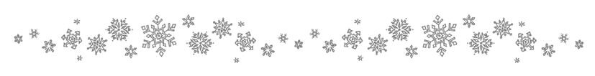Neighborhood VBS 2022
Following Jesus…
Into the Unknown

We, the parents of (List name of child/children below) the child/children listed below to participate in the Neighborhood Vacation Bible School hosted by Jeff and Debbie Smith at 6420 Glebe Point Road, Chesterfield. VA 23838. We assume risks and hazards related to incidental participation, including games and activities related to this particular event. We waive the release and absolve any indemnity and agree to hold harmless any and all volunteers associated with this event or Jeff and Debbie Smith or Jeff Smith Ministries for any claim arising from any injury (or previous injury) or damage to our child.

Name of Child/Children:

Parent/Guardian Signature: ________________________________________________

Date: ____________________

